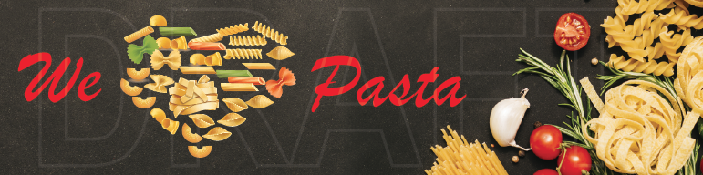
MENU

Gnocchi in a Napoletana Sauce $ 15

Penne Napoletana $ 15

Spaghetti with vegetables in a zucchini cream $ 15

Spaghetti with bacon and mushrooms in a cream sauce $ 15

Rice balls (Arancini) 4 x $ 10

Chips $ 5

Chips and Hot dogs Kids size $ 10

Italian style stew on a bread roll $ 14

